JAVA COLLECTIONS

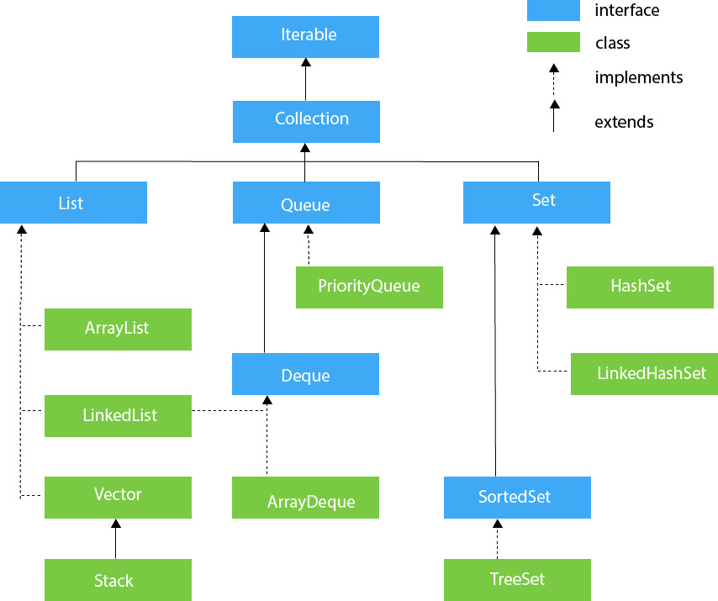

Java Collections Framework (JCF) is a unified architecture for storing, manipulating, and retrieving data in the form of objects. It includes interfaces, classes, and algorithms that handle data structures like lists, sets, queues, and maps, providing various functionalities.

